THE HIBERNATING LIMA: A CASE REPORT DESCRIBING IMPROVEMENT IN LEFT INTERNAL MAMMARY ARTERY GRAFT FLOW AFTER PROGRESSION OF NATIVE VESSEL CORONARY ARTERY DISEASE
S. Desai, B. Louka, F.D. Fortuin
Mayo Clinic Arizona, Department of Cardiovascular Disease, Scottsdale, AZ, USA

Background: The utility of the Internal Mammary Artery as a bypass conduit has been studied in surgical laboratories for more than seventy years. Furthermore, occlusion of the Left Internal Mammary Artery (LIMA) following bypass grafting to a moderately diseased vessel has also been well studied. The hemodynamic effects of competitive flow between involved vessels have long been debated as a mechanism of graft failure. We present a unique case of dynamic LIMA patency when there is progression of coronary disease in a non-Left Anterior Descending (LAD) vessel.
Case: We present a 91 year old male who is 14 years status post coronary artery bypass grafting for multi-vessel coronary artery disease. The LIMA was grafted to the ramus intermediate along with two vein grafts going to a diagonal branch and posterior descending artery. Three years after his bypass surgery, the patient underwent coronary angiography revealing an atretic LIMA graft with a patent ramus intermediate vessel. Eleven years later, the patient again presented with angina and was taken for left heart catheterization. During this instance, LIMA injection revealed a widely patent graft, however, an entirely occluded ramus intermediate vessel.
Discussion: When studying patients with a LIMA bypass graft to the LAD, Nasu et al found that a smaller degree of stenosis in the LAD correlated with less LIMA flow volume⁴. With that said, we suspect that the atretic LIMA in our patient was recruited once the patient had progression of coronary disease in his native ramus intermediate vessel. Although re-establishing flow in the LIMA when there is worsening of native vessel coronary disease has been reported previously, it is not well described in non-LAD vessels. This case highlights the dynamic patency of the LIMA as a bypass conduit, even when grafted to non-LAD vessels.
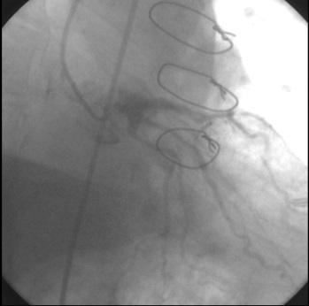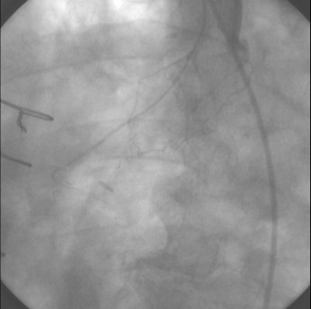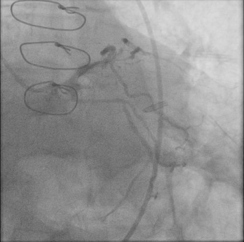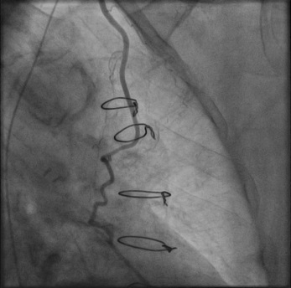
D
C
B
A
Figure 1 A) Left main injection 3 years after CABG revealing patent Ramus Intermediate (arrow). B) Atretic LIMA graft (arrow). C) Angiogram 14 years after CABG revealing occluded Ramus Intermediate (arrow). D) Widely patent LIMA graft (arrow).

